**SISTEM DATABASE II**

**(SDB2-02)**



**Disusun Oleh:**

Prames Ray Lapian - 140810210059

**PROGRAM STUDI S-1 TEKNIK INFORMATIKA**

**FAKULTAS MATEMATIKA DAN ILMU PENGETAHUAN ALAM**

**UNIVERSITAS PADJADJARAN**

**JATINANGOR**

**2022**

1. Create User:
   1. Cek SID anda terlebih dahulu dengan menggunakan Command Prompt seperti gambar dibawah:

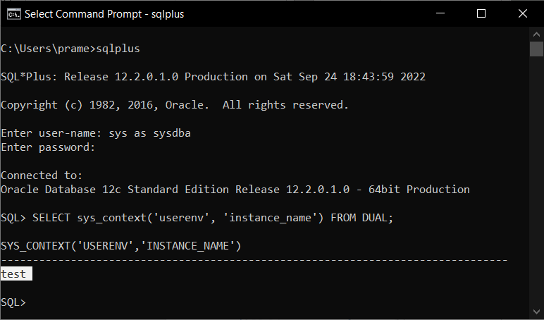

* 1. Lalu anda harus membuat Connection terlebih dahulu:

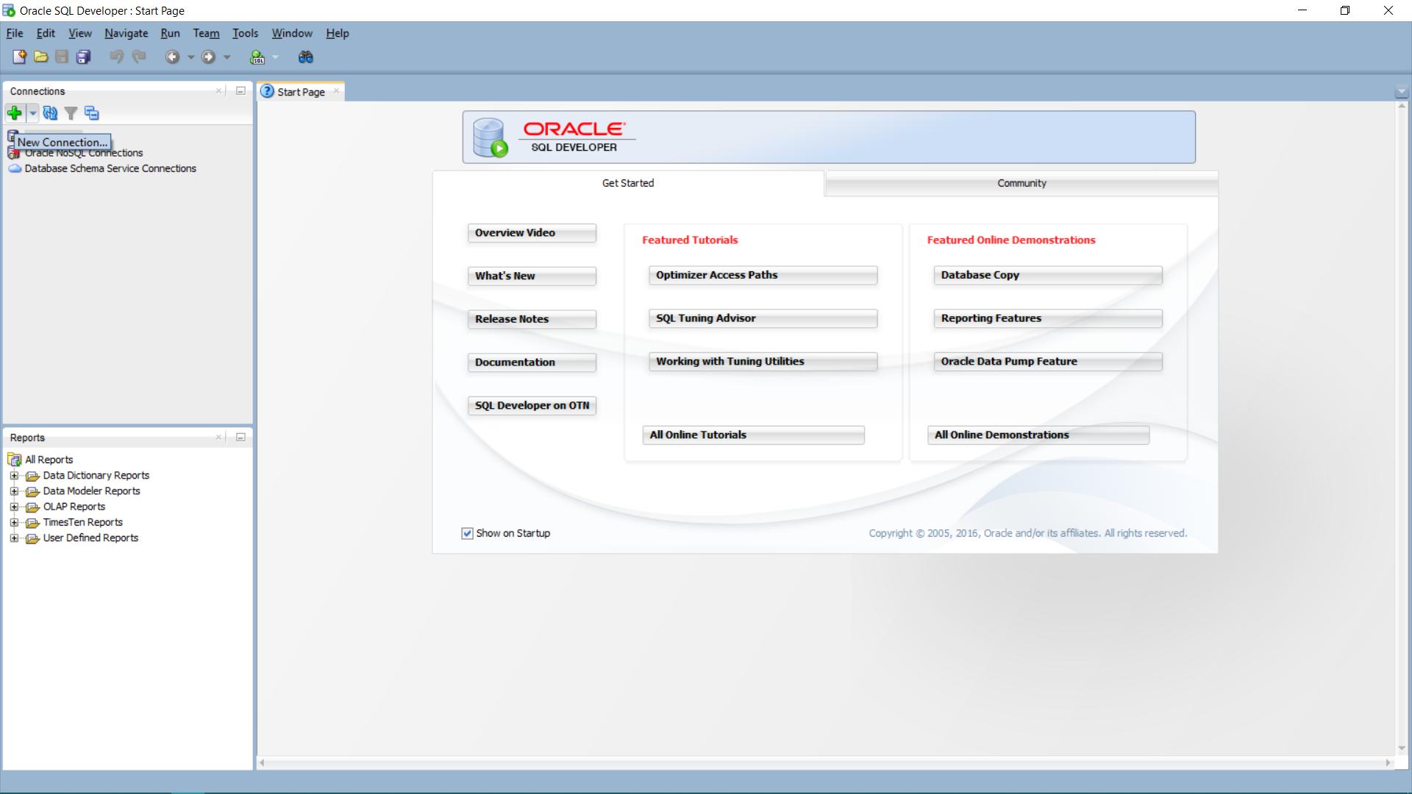

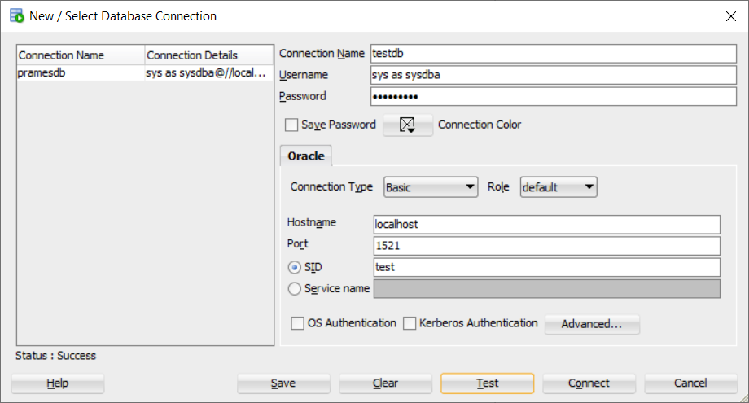

* 1. Lalu anda bisa langsung membuat User Baru menggunakan nama singkat anda:

SELECT * FROM ALL_USERS;

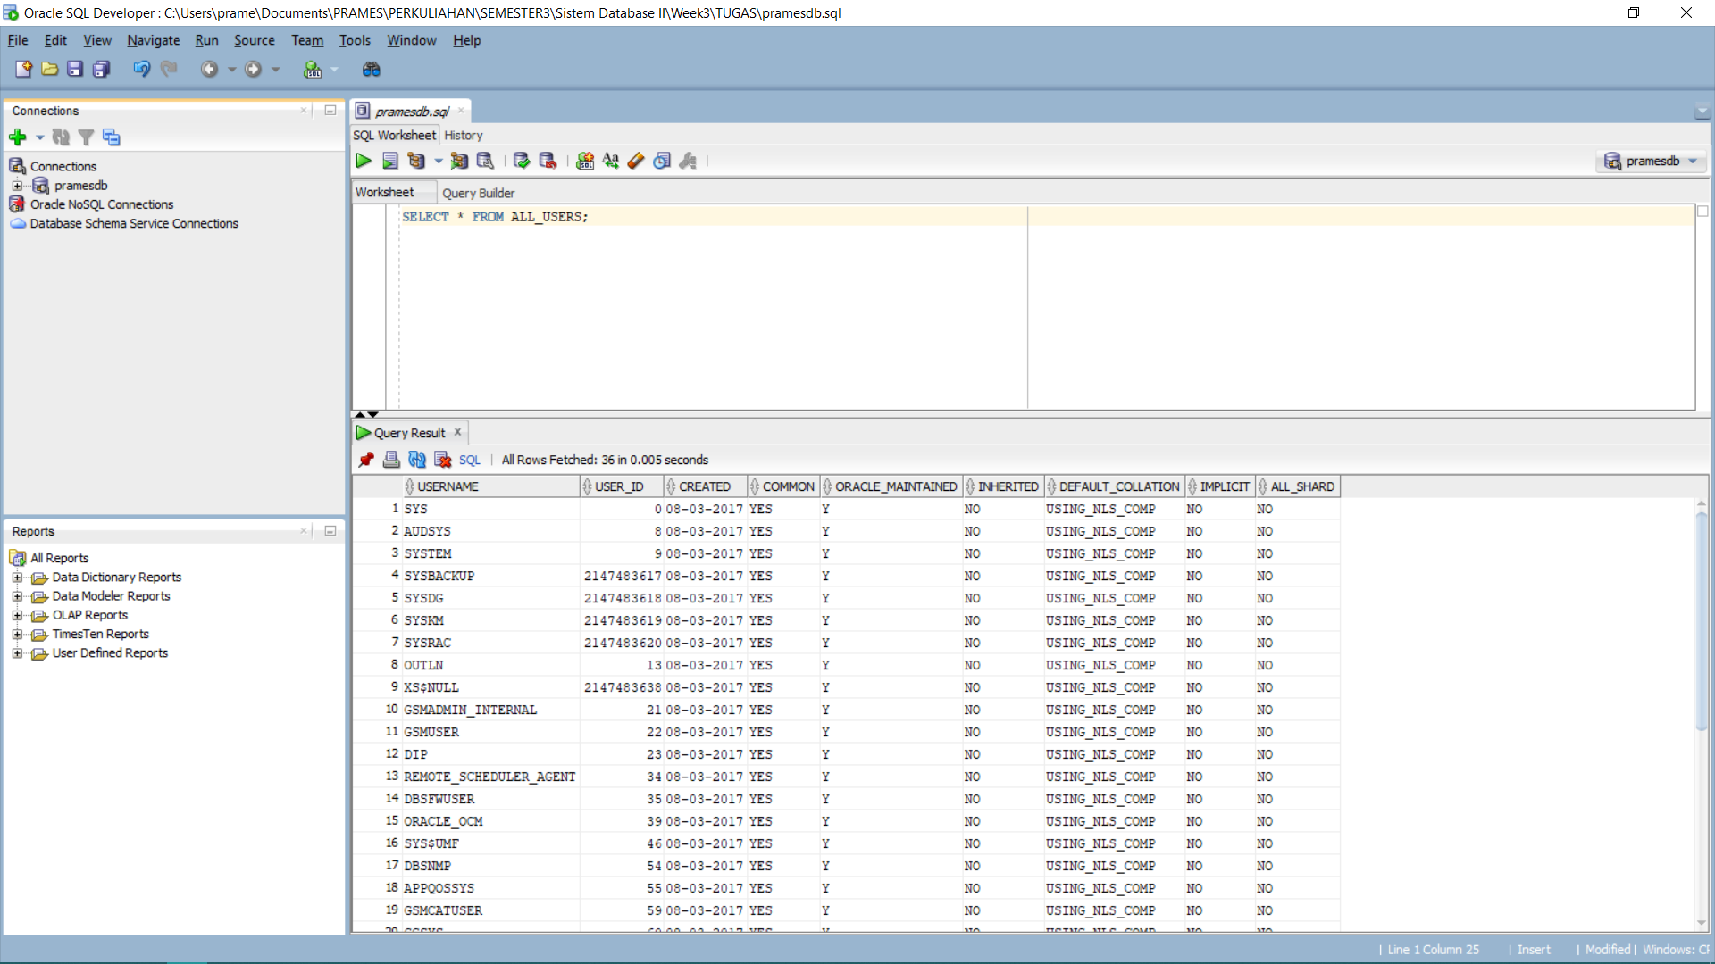

CREATE USER C##<username> IDENTIFIED BY <password>;

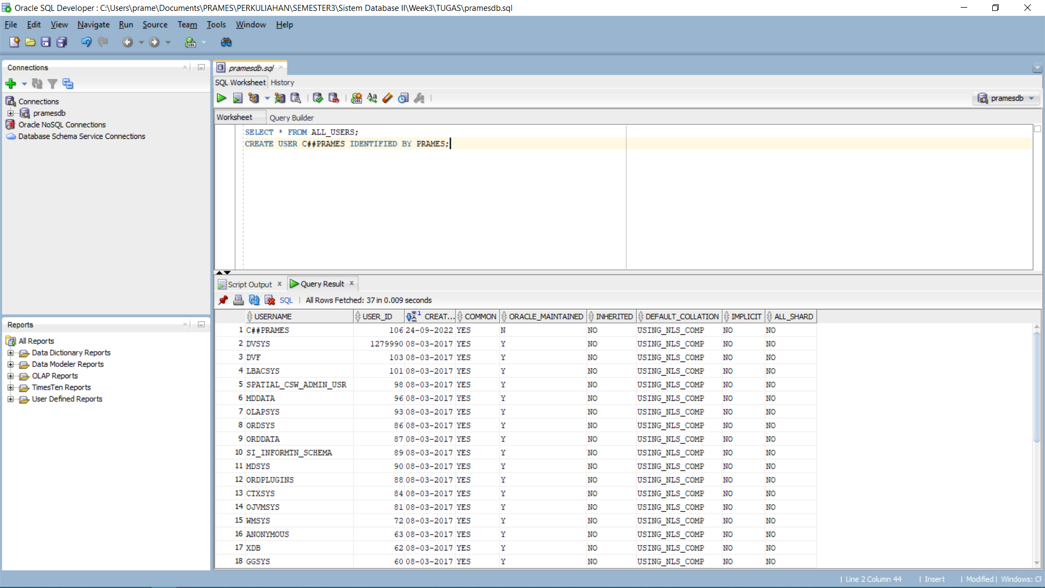

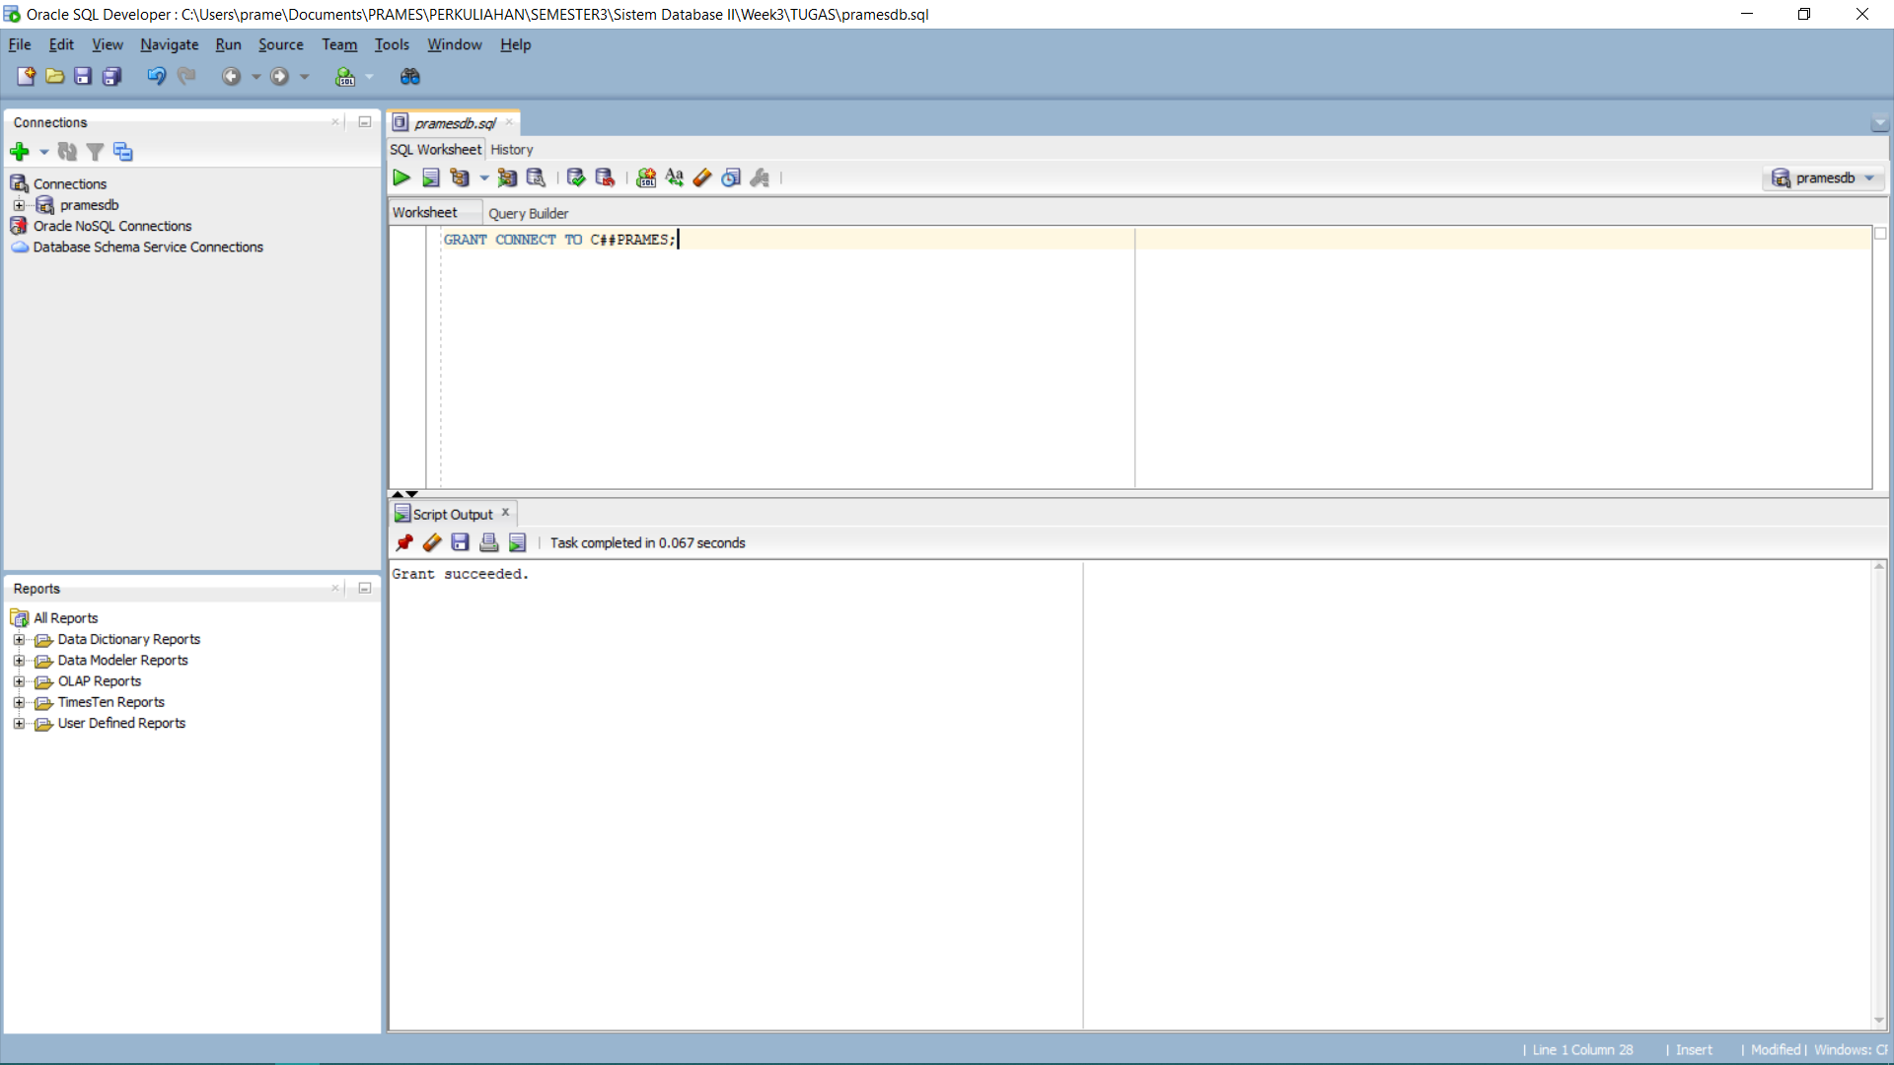

1. Create Table:
   1. Mahasiswa:

CREATE TABLE Mahasiswa (

npm VARCHAR(12) NOT NULL PRIMARY KEY,

nama VARCHAR(30),

jk CHAR(1),

tpt_lhr VARCHAR(20),

tgl_lhr VARCHAR(18),

alamat VARCHAR(50),

no_hp VARCHAR(13),

dsn_wali VARCHAR(30));

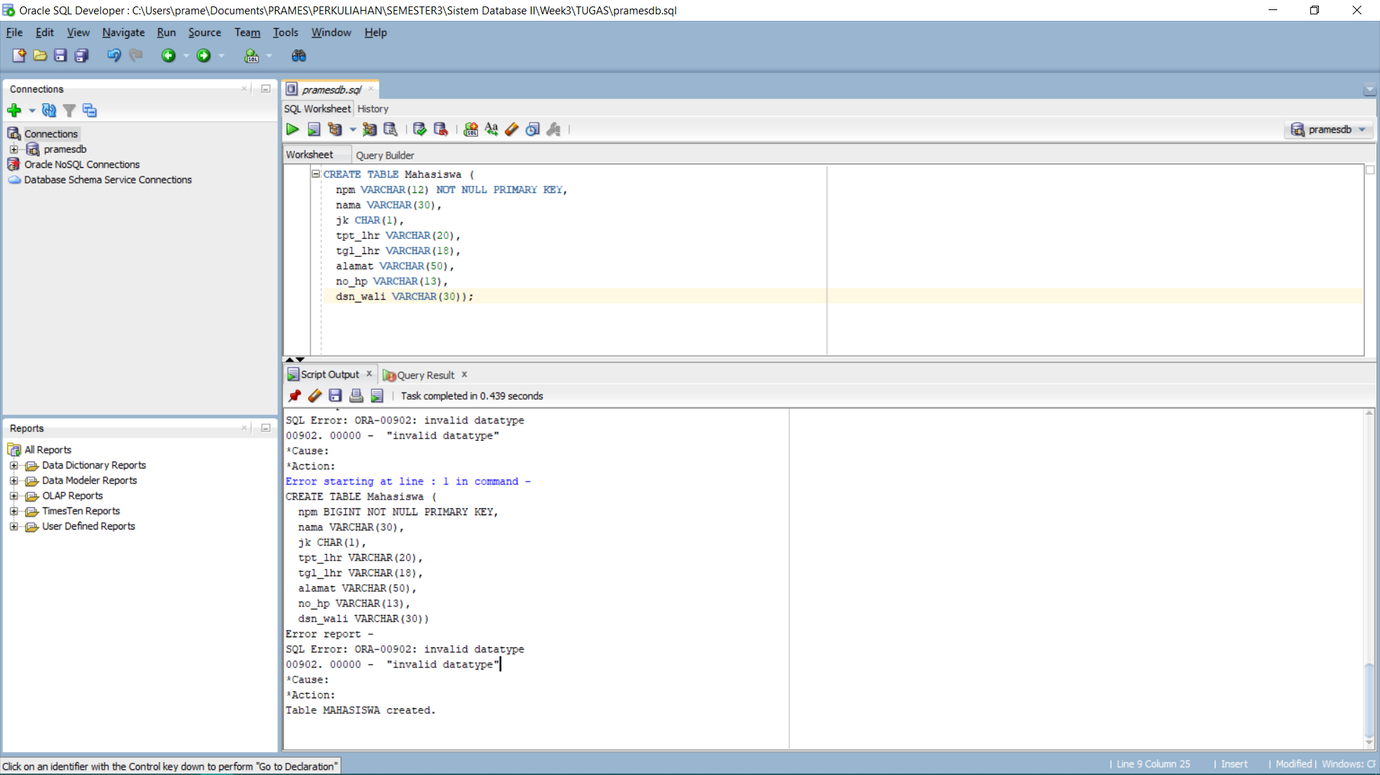

* 1. Dosen:

CREATE TABLE Dosen (

sandi_dsn VARCHAR(10) NOT NULL PRIMARY KEY,

nama VARCHAR(50),

jk CHAR(1),

nip VARCHAR(12),

alamat VARCHAR(50),

no_hp VARCHAR(13));

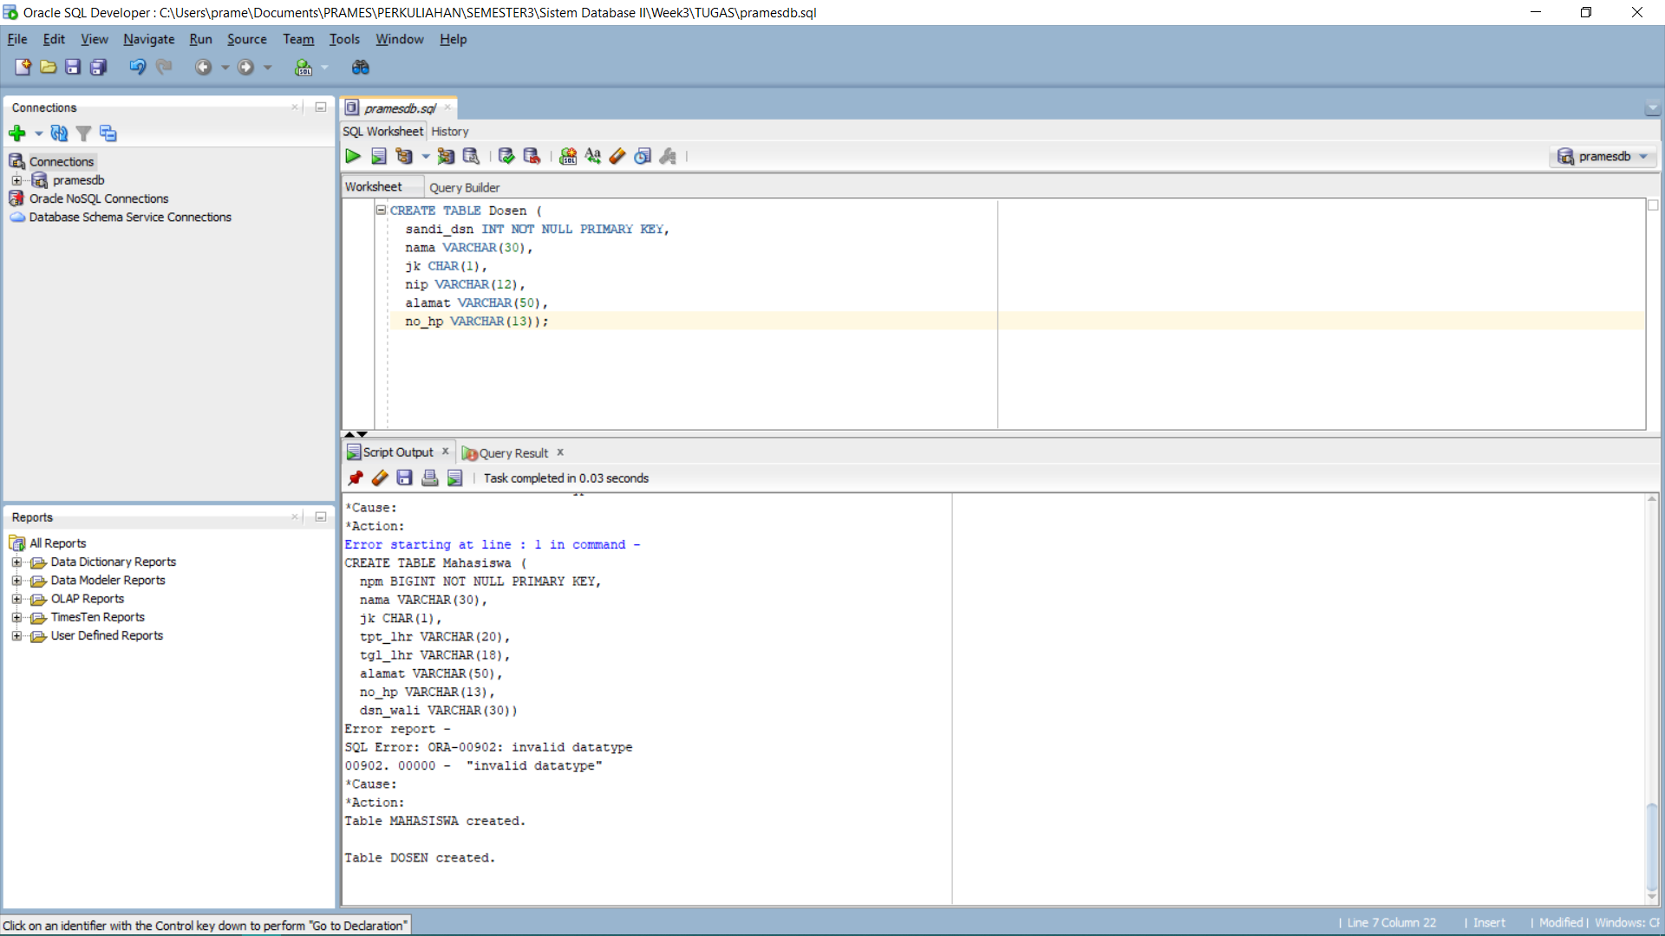

* 1. Kuliah:

CREATE TABLE Kuliah (

kd_mk VARCHAR(15) NOT NULL PRIMARY KEY,

nama_mk VARCHAR(30),

SKS INT,

kurikulum VARCHAR(20));

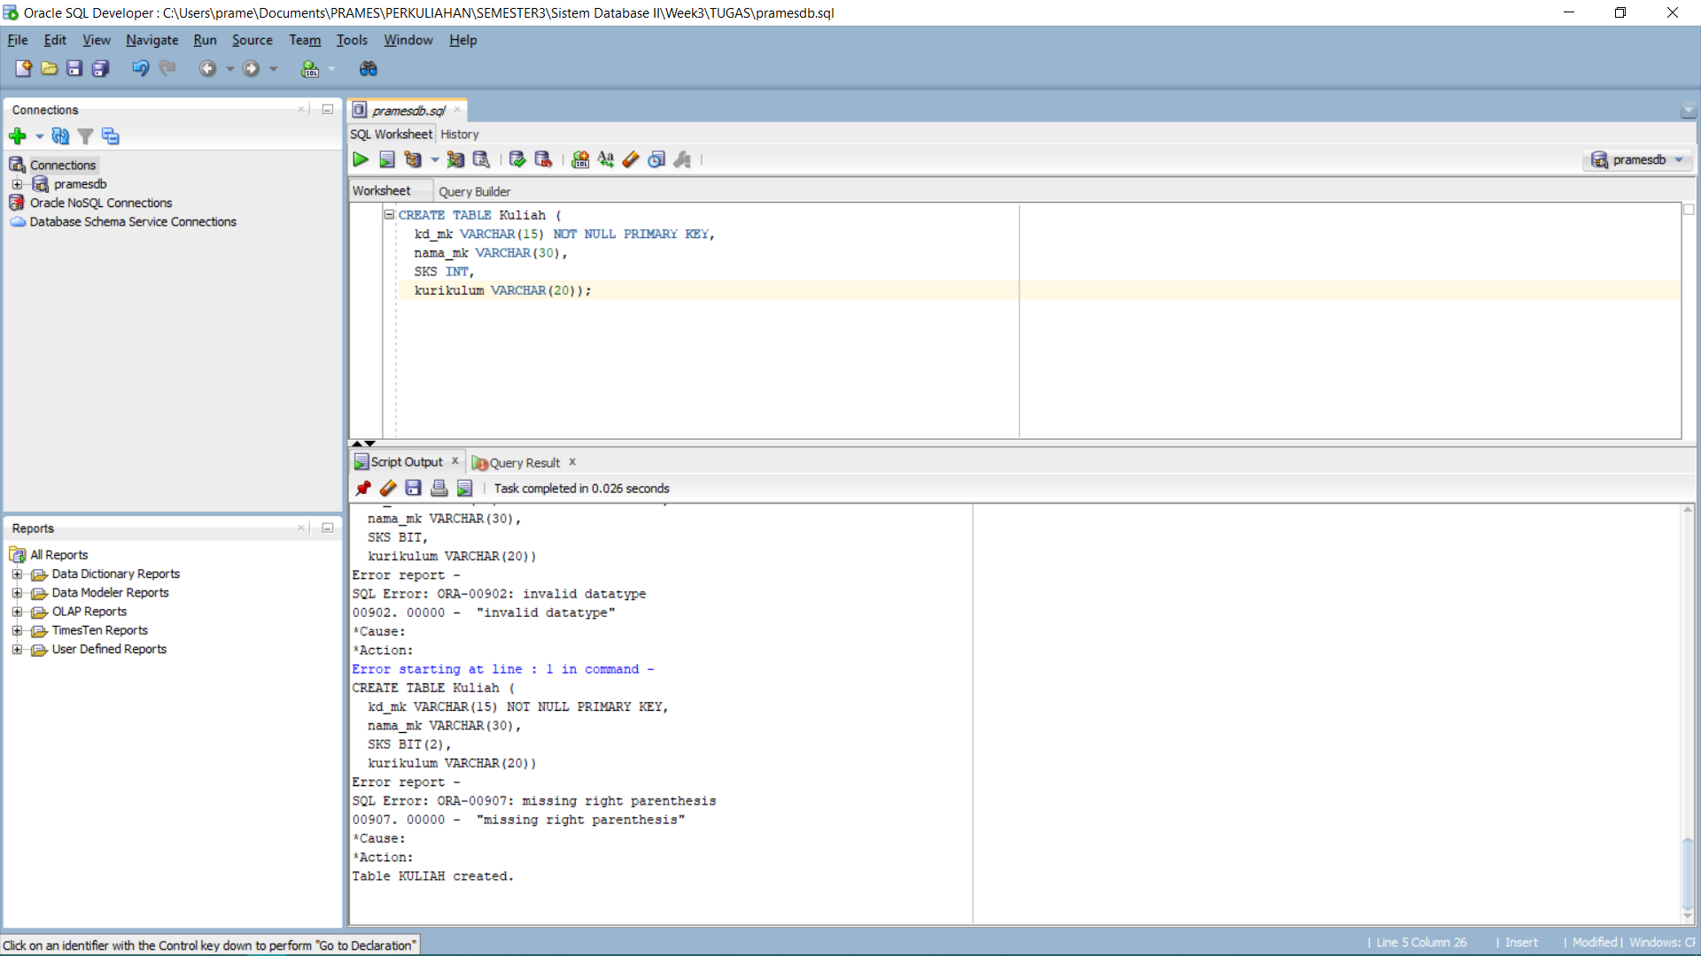

* 1. Krs:

CREATE TABLE krs (

smt VARCHAR(10)NOT NULL PRIMARY KEY,

npm VARCHAR(12),

kd_mk VARCHAR(15),

nilai FLOAT,

FOREIGN KEY (npm) REFERENCES Mahasiswa(npm),

FOREIGN KEY (kd_mk) REFERENCES Kuliah(kd_mk));

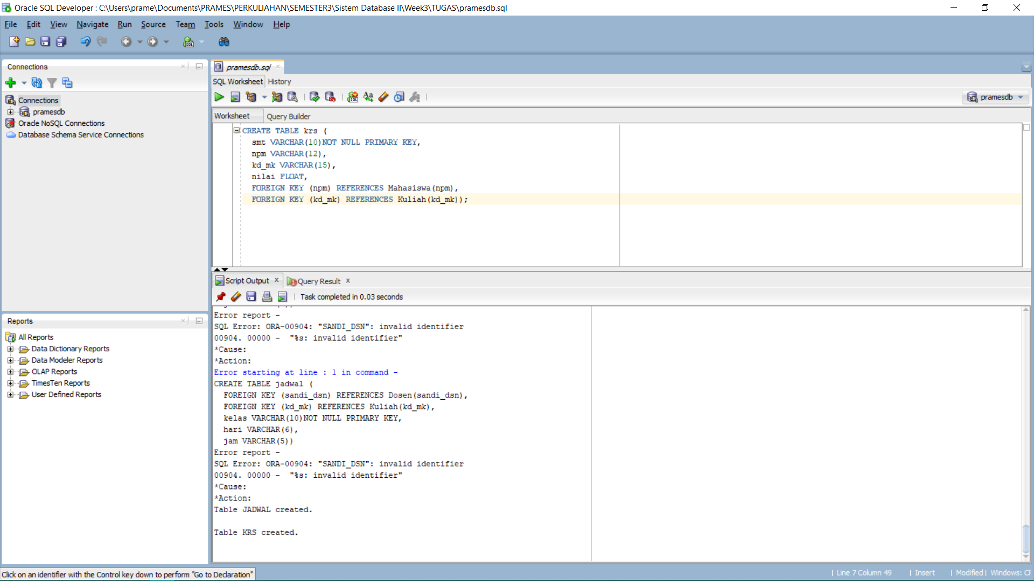

* 1. Jadwal:

CREATE TABLE jadwal (

sandi_dsn VARCHAR(10),

kd_mk VARCHAR(15),

kelas VARCHAR(10)NOT NULL PRIMARY KEY,

hari VARCHAR(6),

jam VARCHAR(5),

FOREIGN KEY (sandi_dsn) REFERENCES Dosen(sandi_dsn),

FOREIGN KEY (kd_mk) REFERENCES Kuliah(kd_mk));

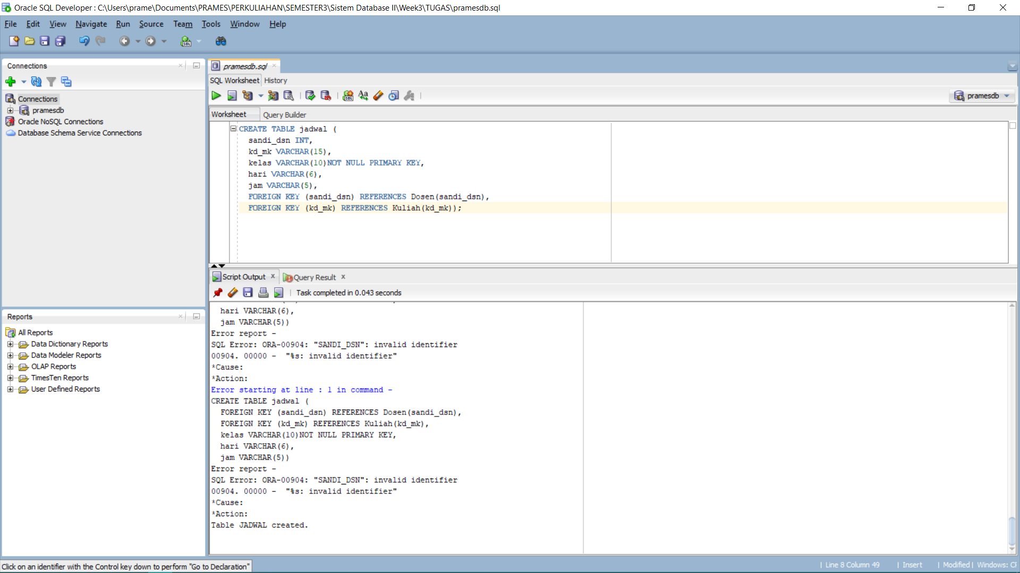

1. Desc Table:
   1. Mahasiswa:

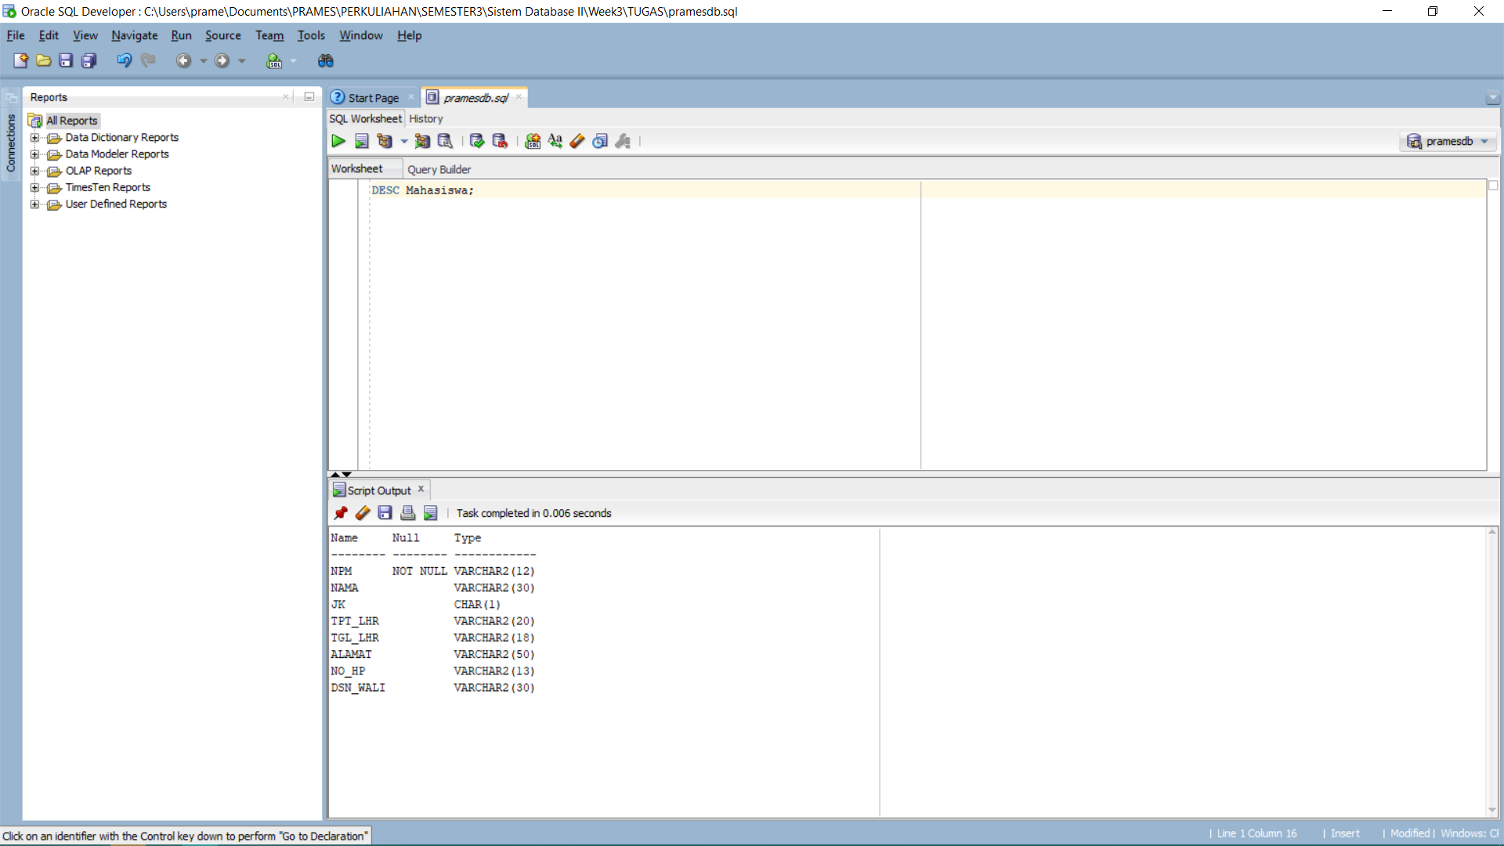

* 1. Dosen:

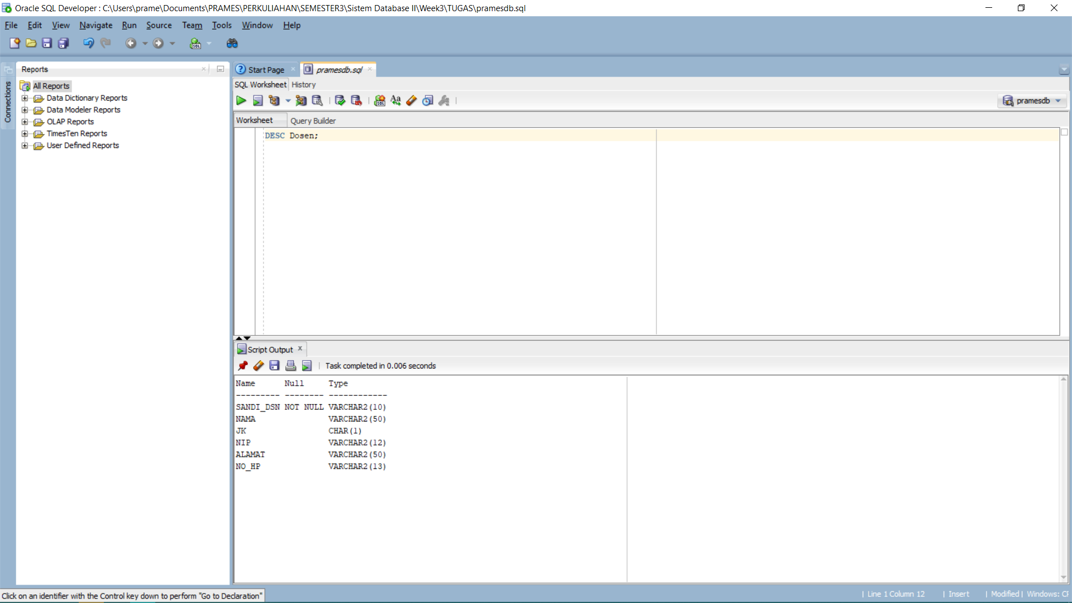

* 1. Kuliah:

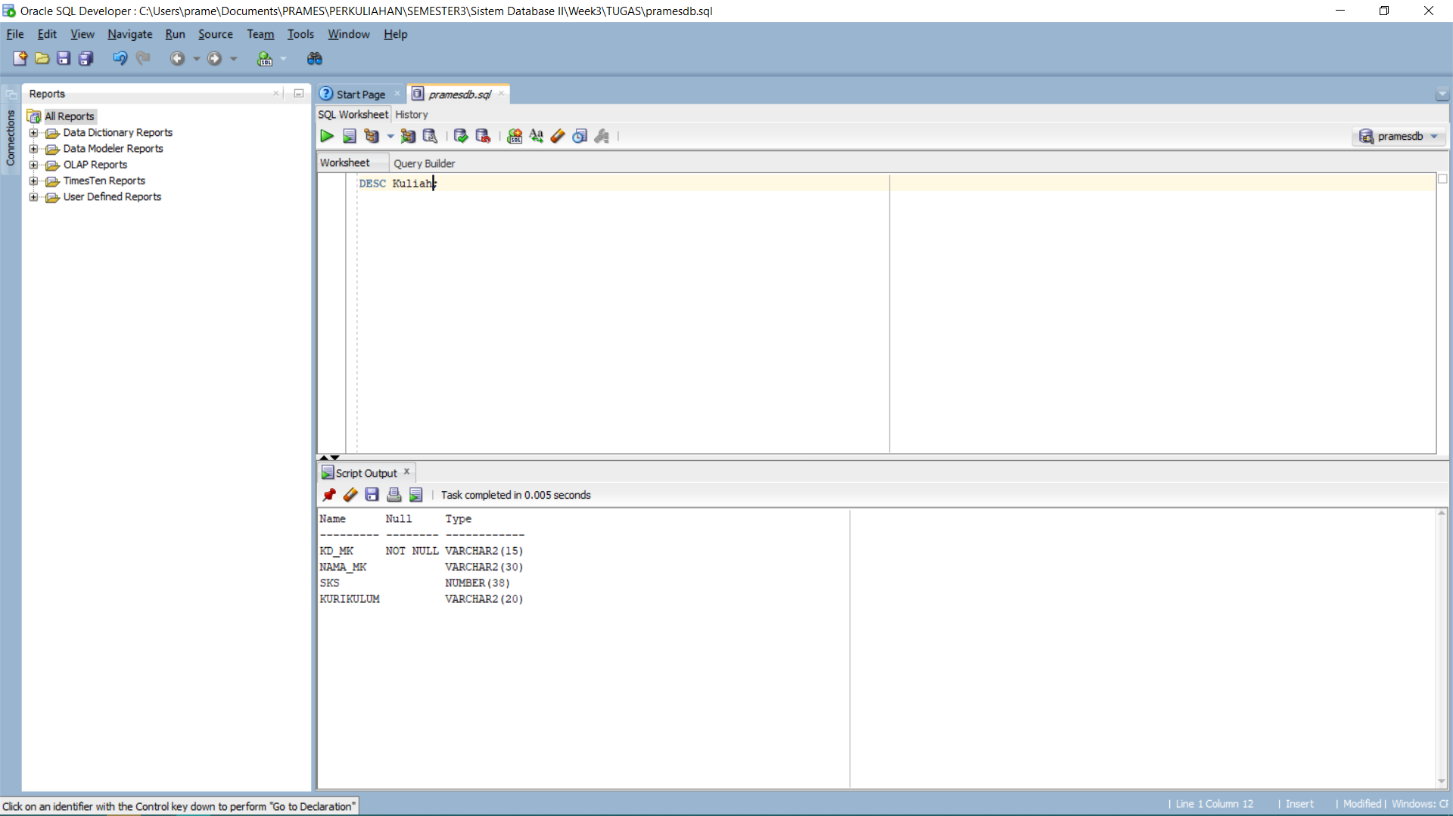

* 1. Krs:

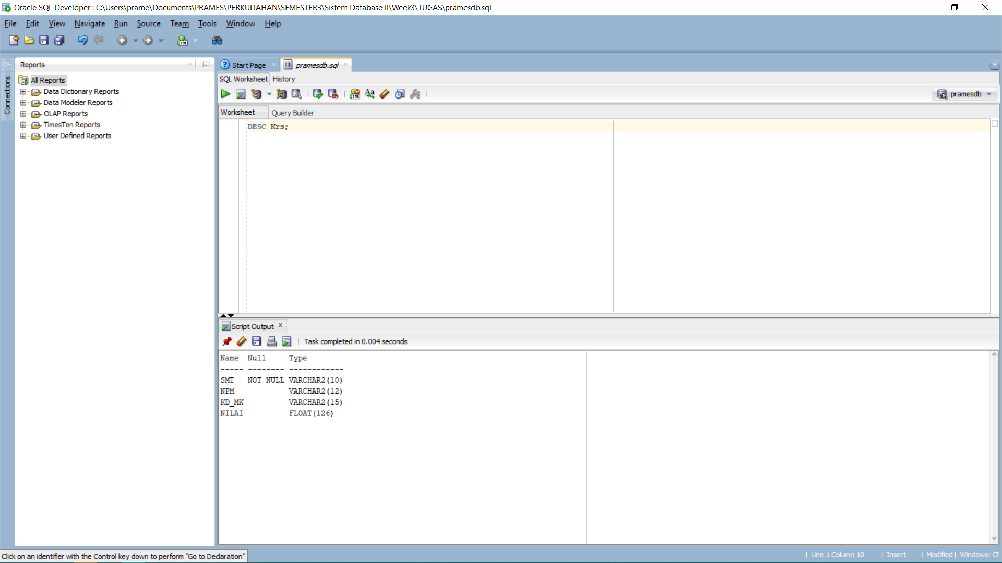

* 1. Jadwal:

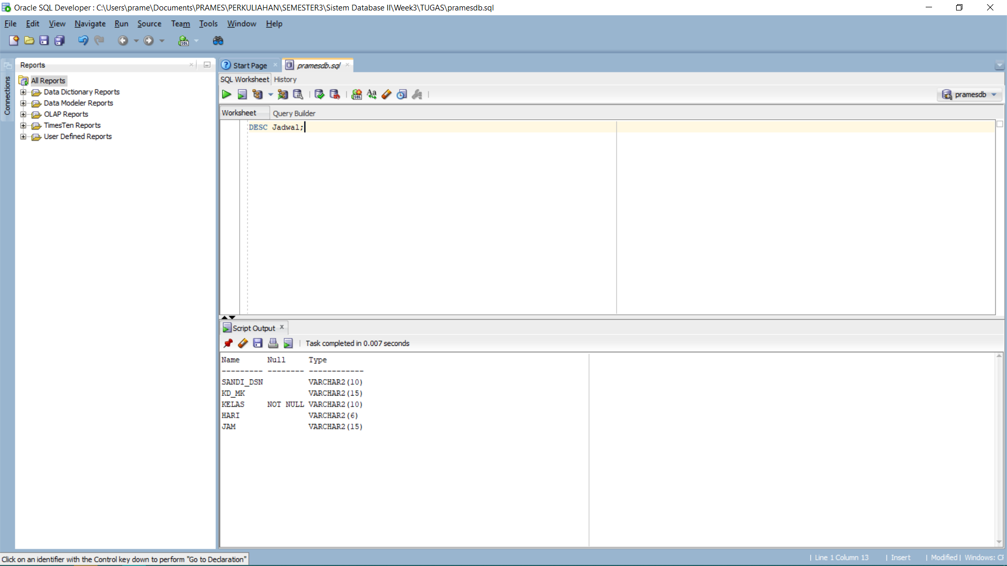

1. Inser Into Table:
   1. Mahasiswa:

INSERT INTO Mahasiswa

VALUES ('140810210059',

'Prames Ray Lapian',

'L',

'Jakarta',

'16 Maret 2004',

'Kebon Baru Gg.1 Blok R No.38',

'082299958474',

'Deni Setiana');

SELECT * FROM Mahasiswa;

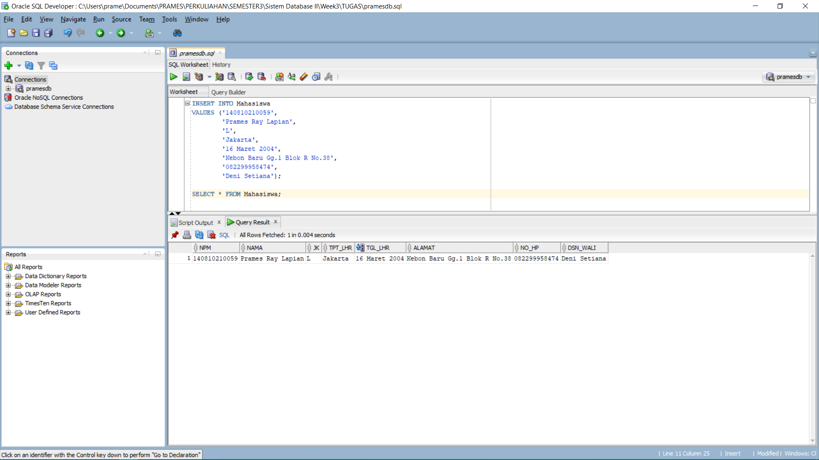

* 1. Dosen:

INSERT INTO Dosen

VALUES ('D03B10007',

'Dr. Juli Rejito, M.Kom.',

'L',

'19680717 ',

'Unknown',

'Unknown');

INSERT INTO Dosen

VALUES ('D03B10009',

'Deni Setiana, S.Si., M.Cs.',

'L',

'19730925',

'Unkown',

'08882006926');

INSERT INTO Dosen

VALUES ('D10A10024',

'Anita Triska, S.Si., M.Si',

'P',

'19831228',

'Unknown',

'Unknown');

INSERT INTO Dosen

VALUES ('2D03B10007',

'Akmal, S.Si., M.T.',

'L',

'19700615',

'Unknown',

'Unknown');

INSERT INTO Dosen

VALUES ('D03C10003',

'Akik Hidayat, Drs., M.Kom.',

'L',

'19611018',

'Unknown',

'Unknown');

INSERT INTO Dosen

VALUES ('D03C10007',

'Rudi Rosadi, S.Si., M.Kom.',

'L',

'19760723',

'Unknown',

'Unknown');

INSERT INTO Dosen

VALUES ('D03B10002',

'R. Sudrajat, Drs., M.Si.',

'L',

'19600212',

'Unknown',

'Unknown');

INSERT INTO Dosen

VALUES ('-',

'Rahmatullah Arrizal Pranatadesta',

'L',

'-',

'Unknown',

'Unknown');

INSERT INTO Dosen

VALUES ('D03B10003',

'Ino Suryana, Drs., M.Komp.',

'L',

'19600115',

'Unknown',

'Unknown');

SELECT * FROM Dosen;

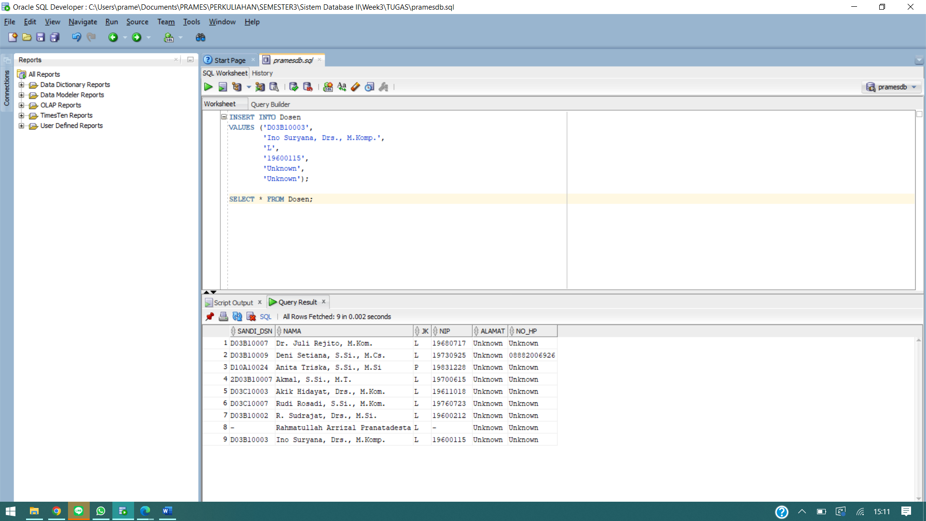

* 1. Kuliah:

INSERT INTO Kuliah

VALUES ('D10K.0400305 ',

'Sistem Database II',

'2',

'2017');

INSERT INTO Kuliah

VALUES ('D10.0400302',

'Aljabar Linier',

'3',

'2017');

INSERT INTO Kuliah

VALUES ('D10K-3003',

'Pemrograman Web',

'3',

'2017');

INSERT INTO Kuliah

VALUES ('D10A.0400304',

'Matematika Diskrit',

'3',

'2017');

INSERT INTO Kuliah

VALUES ('D10K-3002',

'Pemrograman Berorientasi Objek',

'3',

'2017');

INSERT INTO Kuliah

VALUES ('D10K-5003',

'Entrepreneurship',

'2',

'2017');

INSERT INTO Kuliah

VALUES ('D10K-3001',

'Sistem Operasi',

'3',

'2017');

INSERT INTO Kuliah

VALUES ('D10A.0400303',

'Metode Numerik',

'3',

'2017');

SELECT * FROM Kuliah;

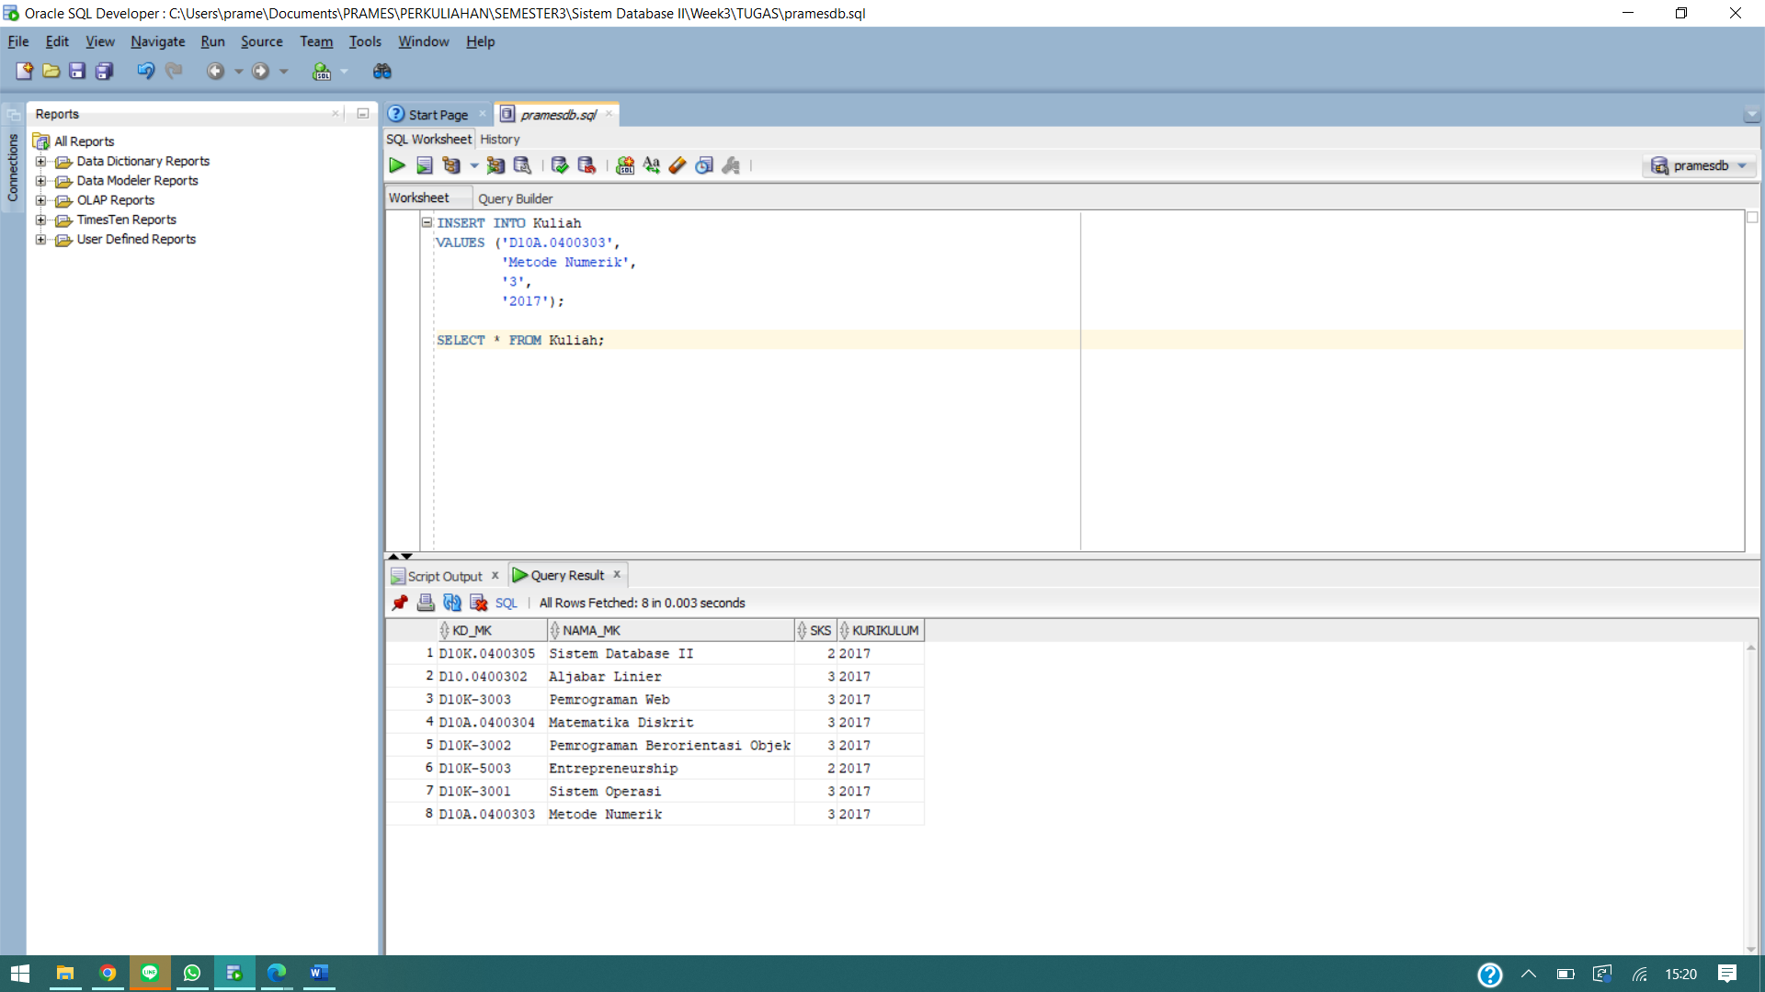

* 1. Krs:

INSERT INTO krs

VALUES ('3',

'140810210059',

'D10K.0400305 ',

0);

INSERT INTO krs

VALUES ('3',

'140810210059',

'D10.0400302',

0);

INSERT INTO krs

VALUES ('3',

'140810210059',

'D10K-3003',

0);

INSERT INTO krs

VALUES ('3',

'140810210059',

'D10A.0400304',

0);

INSERT INTO krs

VALUES ('3',

'140810210059',

'D10K-3002',

0);

INSERT INTO krs

VALUES ('3',

'140810210059',

'D10K-5003',

0);

INSERT INTO krs

VALUES ('3',

'140810210059',

'D10K-3001',

0);

INSERT INTO krs

VALUES ('3',

'140810210059',

'D10A.0400303',

0);

SELECT * FROM krs;

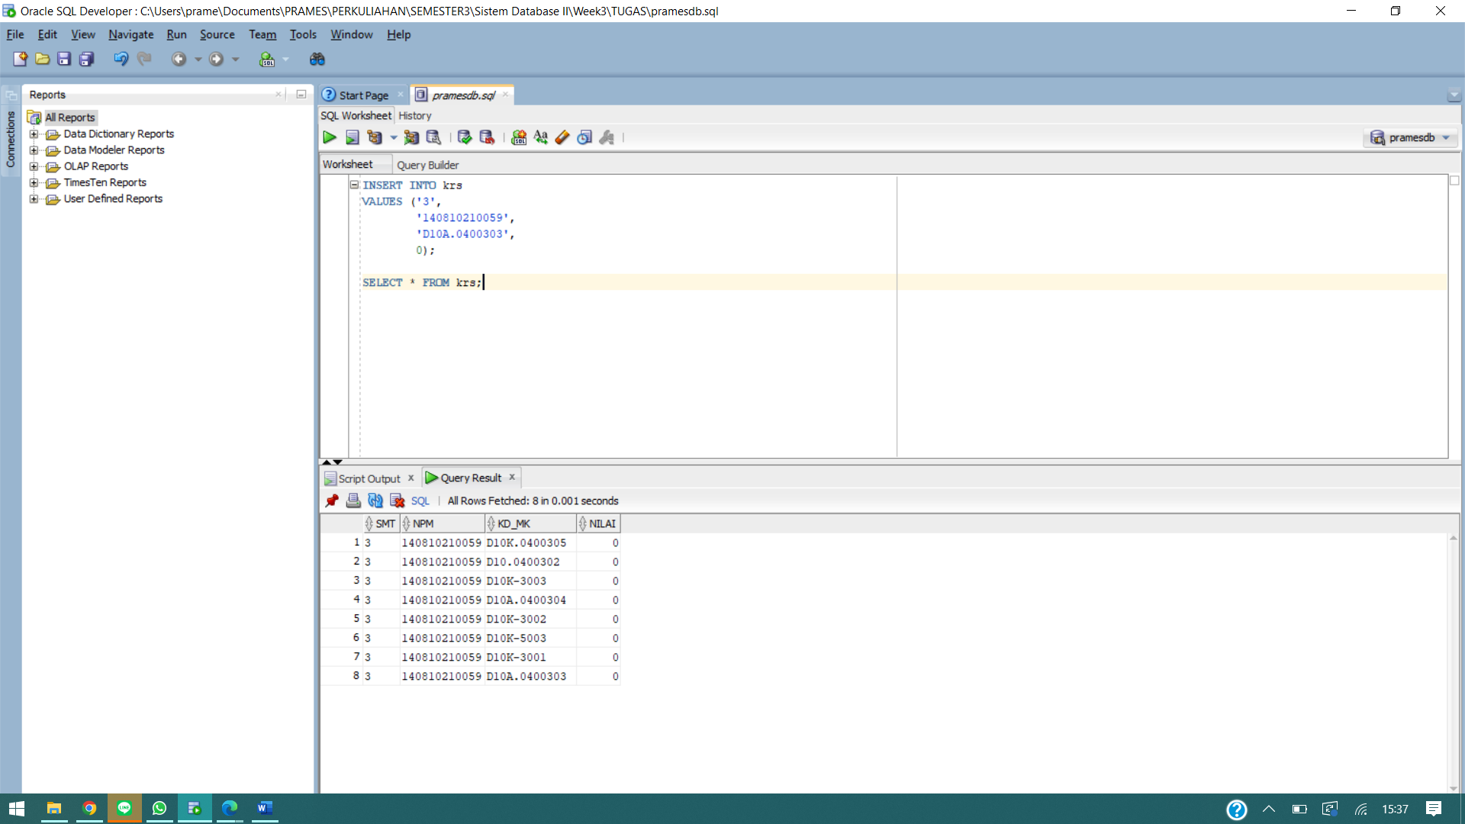

* 1. Jadwal:

INSERT INTO jadwal

VALUES ('D03B10007',

'D10K.0400305 ',

'A',

'Senin',

'08.00-09.40');

INSERT INTO jadwal

VALUES ('D10A10024',

'D10.0400302',

'A',

'Senin',

'13:30 - 16:00');

INSERT INTO jadwal

VALUES ('D03C10007',

'D10K-3003',

'A',

'Selasa',

'08:00 - 10:30');

INSERT INTO jadwal

VALUES ('D03C10003',

'D10A.0400304',

'A',

'Selasa',

'13:30 - 16:00');

INSERT INTO jadwal

VALUES ('2D03B10007',

'D10K-3002',

'A',

'Kamis',

'08:00 - 10:30');

INSERT INTO jadwal

VALUES ('D03B10002',

'D10K-5003',

'A',

'Kamis',

'10:45 - 12:25');

INSERT INTO jadwal

VALUES ('-',

'D10K-3001',

'A',

'Jumat',

'08:00 - 10:30');

INSERT INTO jadwal

VALUES ('D03B10003',

'D10A.0400303',

'A',

'Jumat',

'13:00 - 15:30');

SELECT * FROM jadwal;

